Jenkin Installation:

Click on below link to download

<https://www.jenkins.io/download/>

## under Downloading Jenkins

**Download Jenkins 2.414.2 LTS for:**

**In this section click on windows(Based on your operating system)**

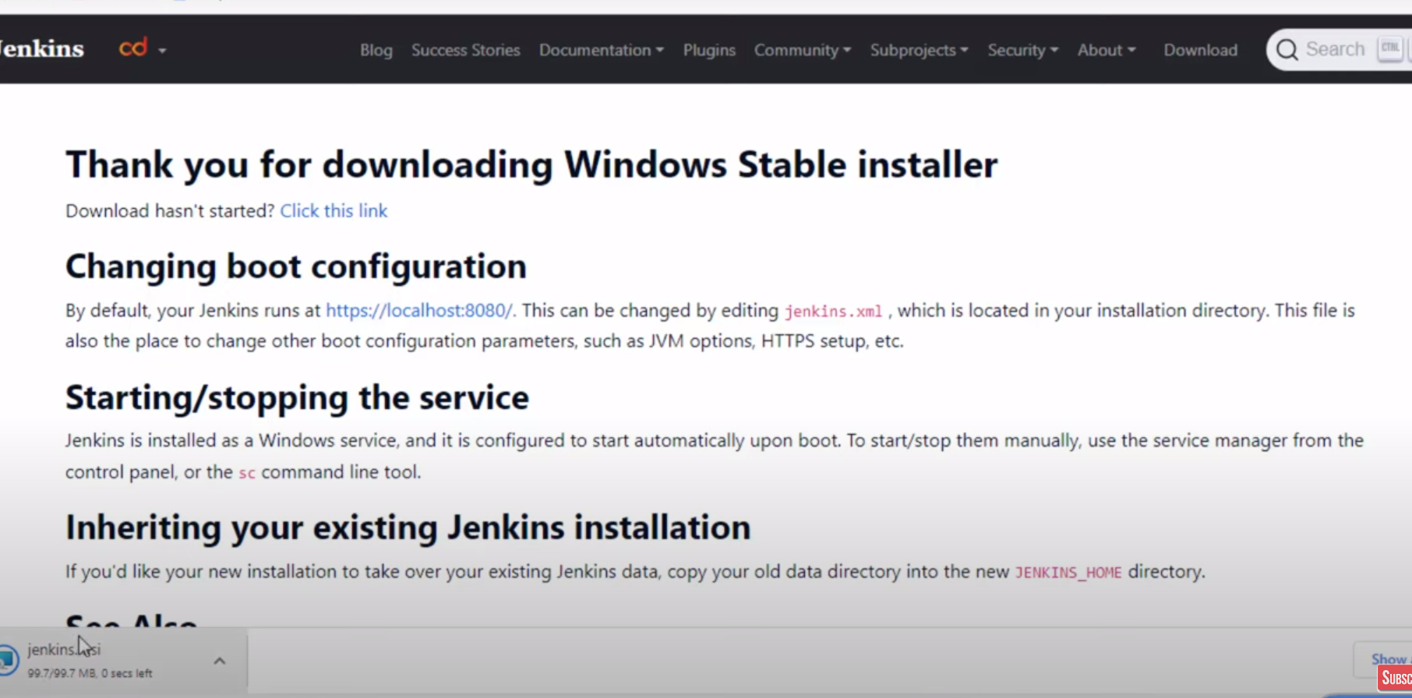

Jenkins is getting downloaded

File is Jenkins.msi file.

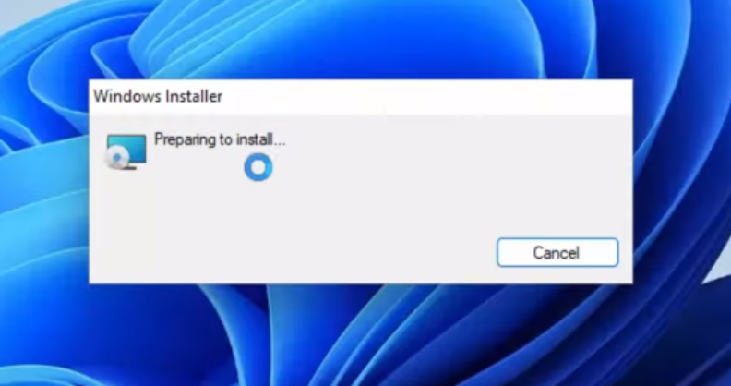

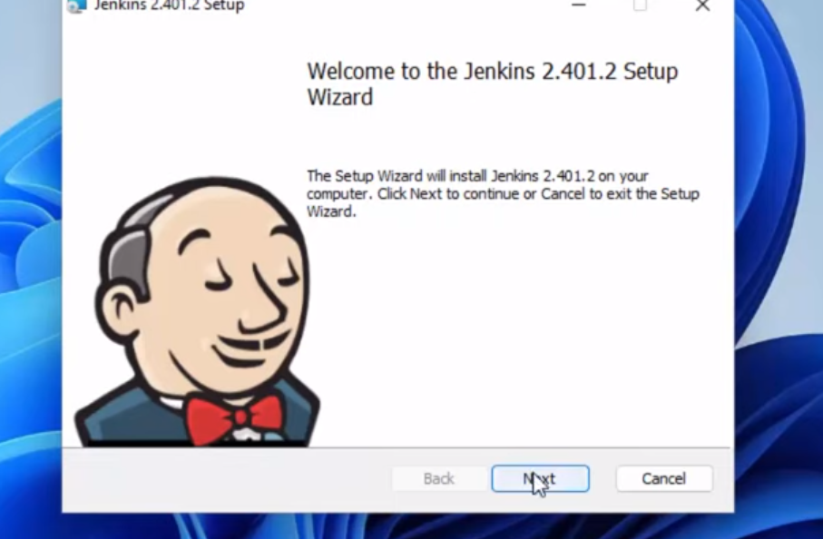

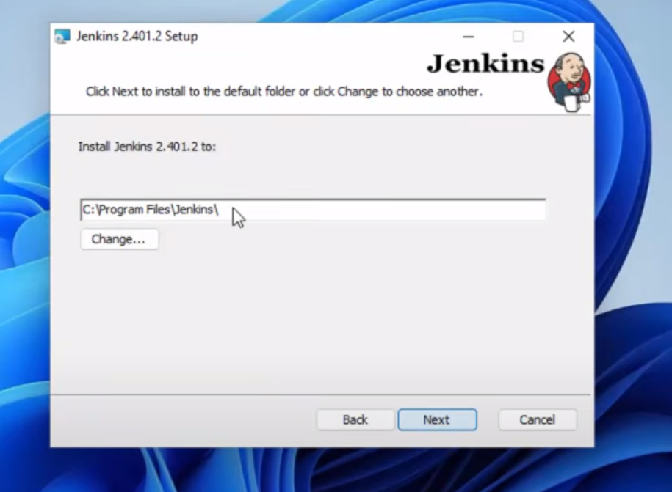

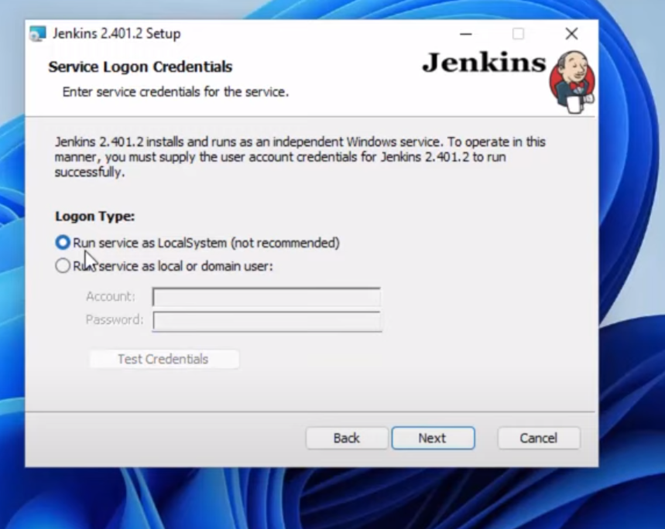

Select Run services as LocalSystem(not recommended)

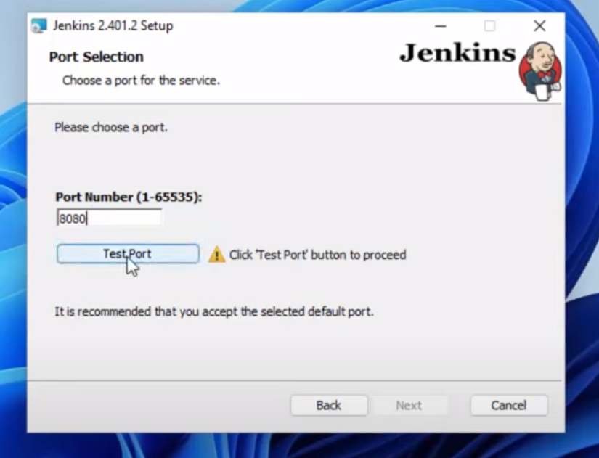

Click the Test Port if no error is giving then ok. Other wise change the port number.

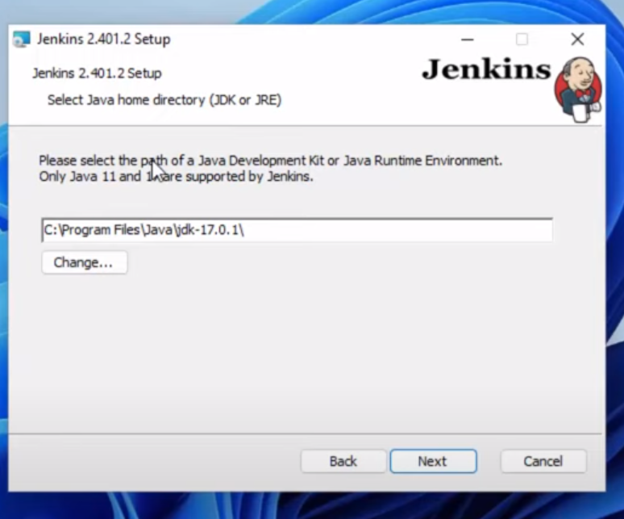

Its important as it supports the jdk-17 only. Make sure it.

Latest 20 jdk version is not supporting, Please consider this.

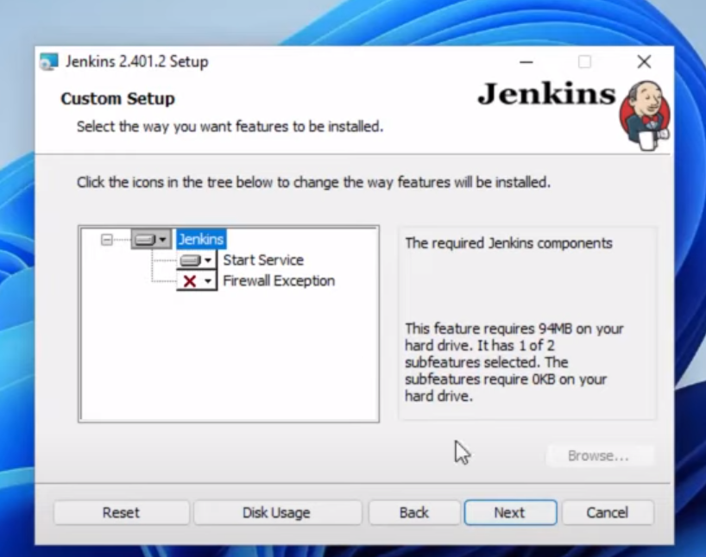

Click on next and then click on install

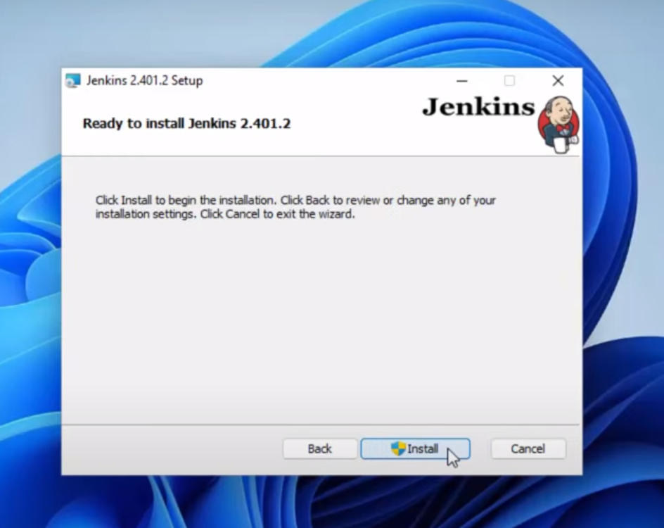

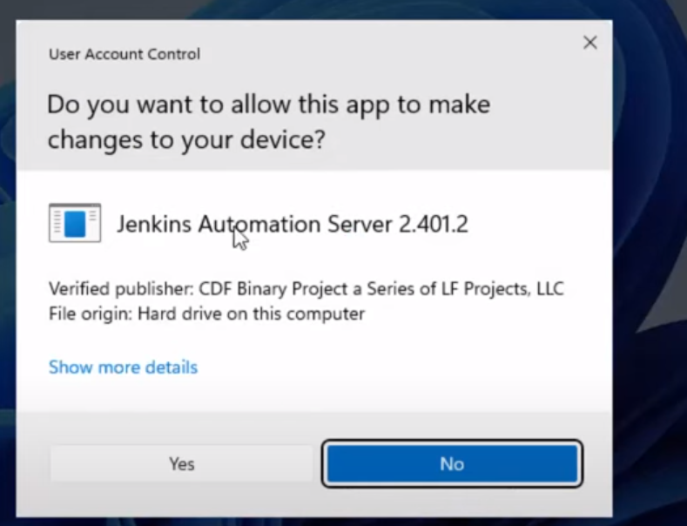

Click yes it it is aksing for the permission.

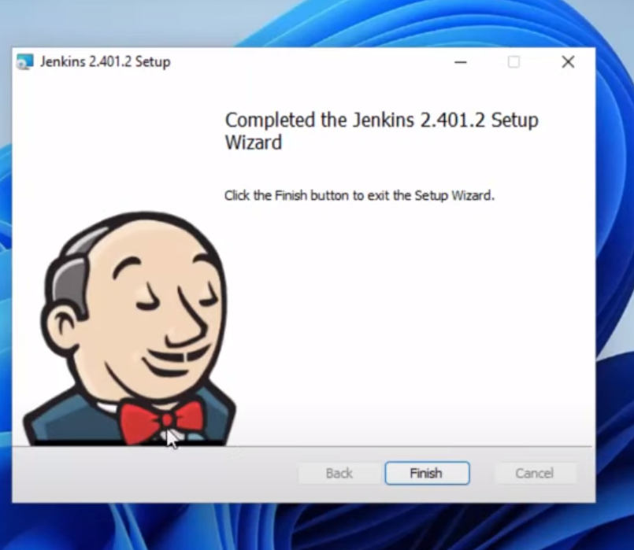

Go back to our web page which we are downloaded the Jenkins.

Click on the localhost:8080 link

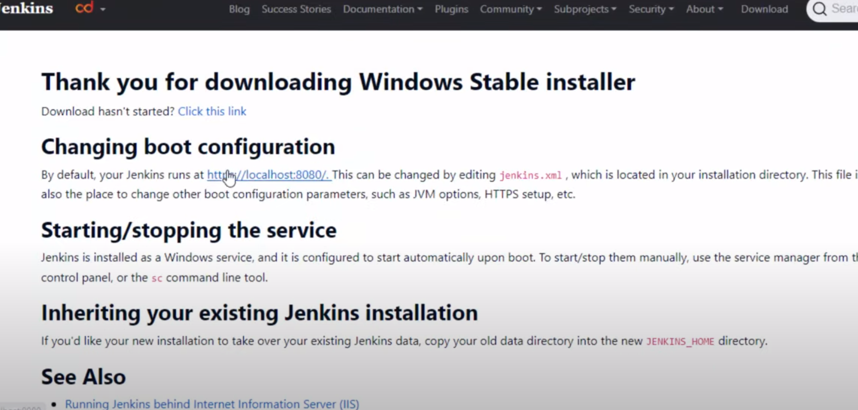

If Jenkins installation is perfect then

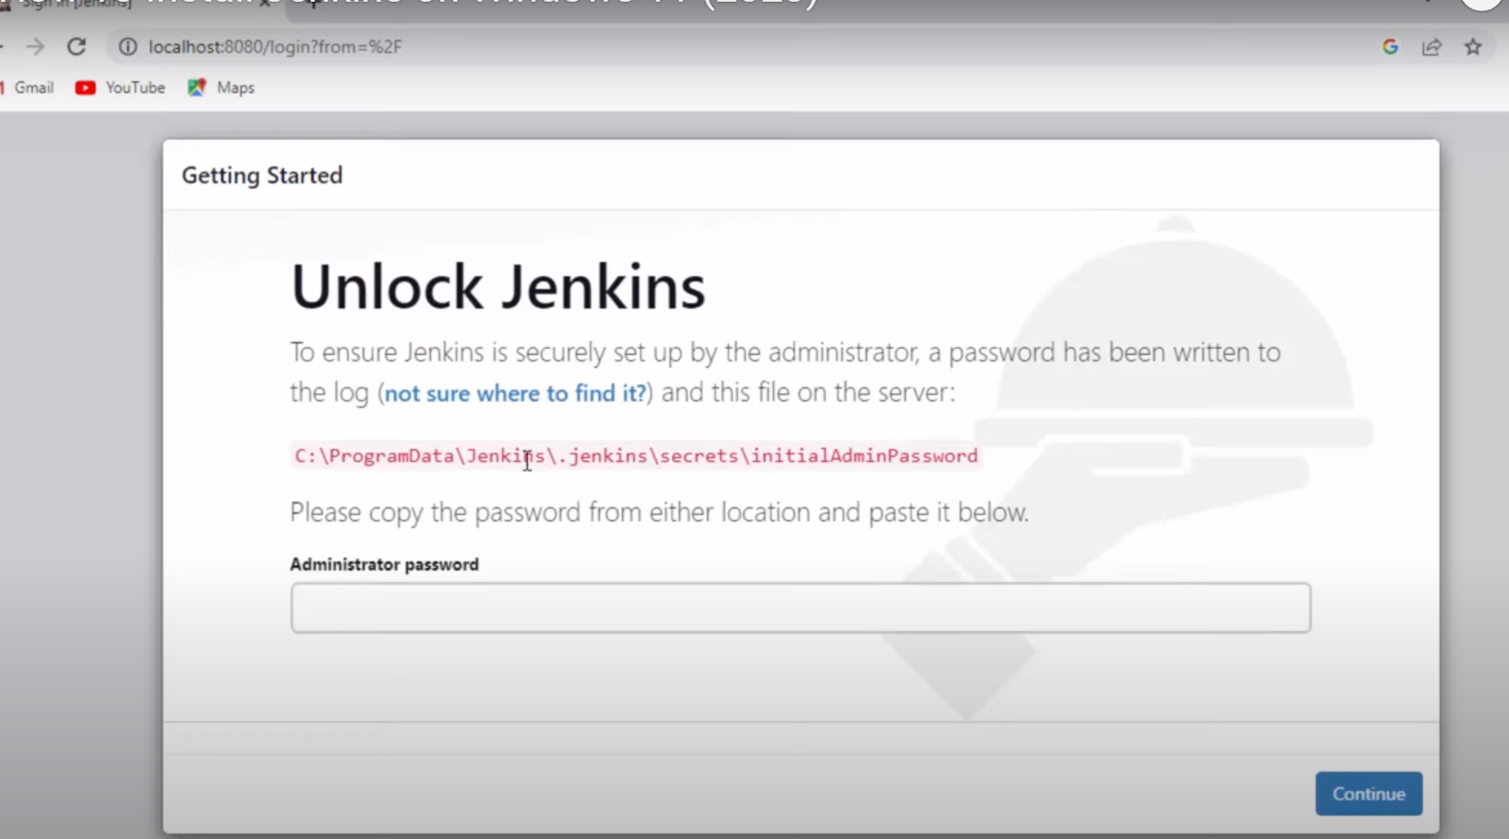

Copy the path as mentioned which is underlined in color below:

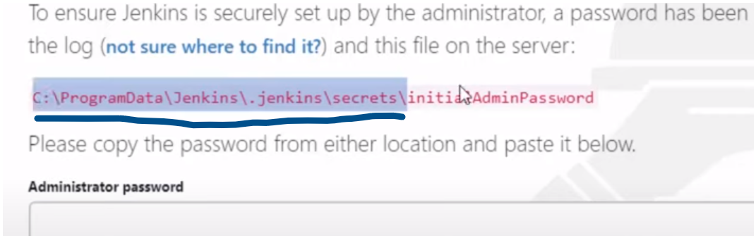

Go to the path.

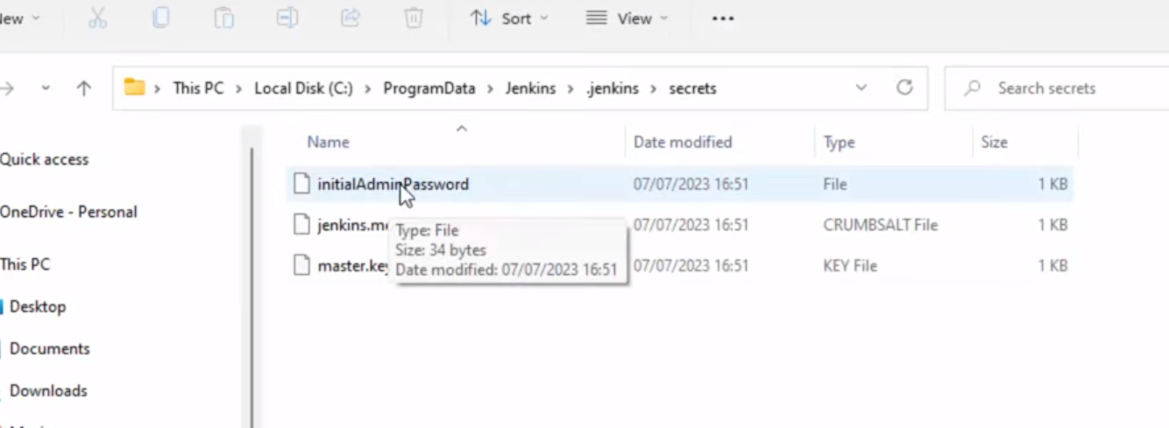

Open intialAdminPassword and copy the password

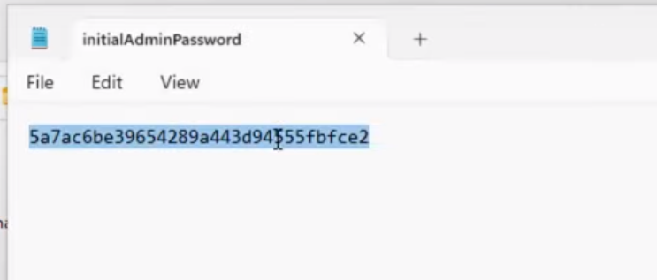

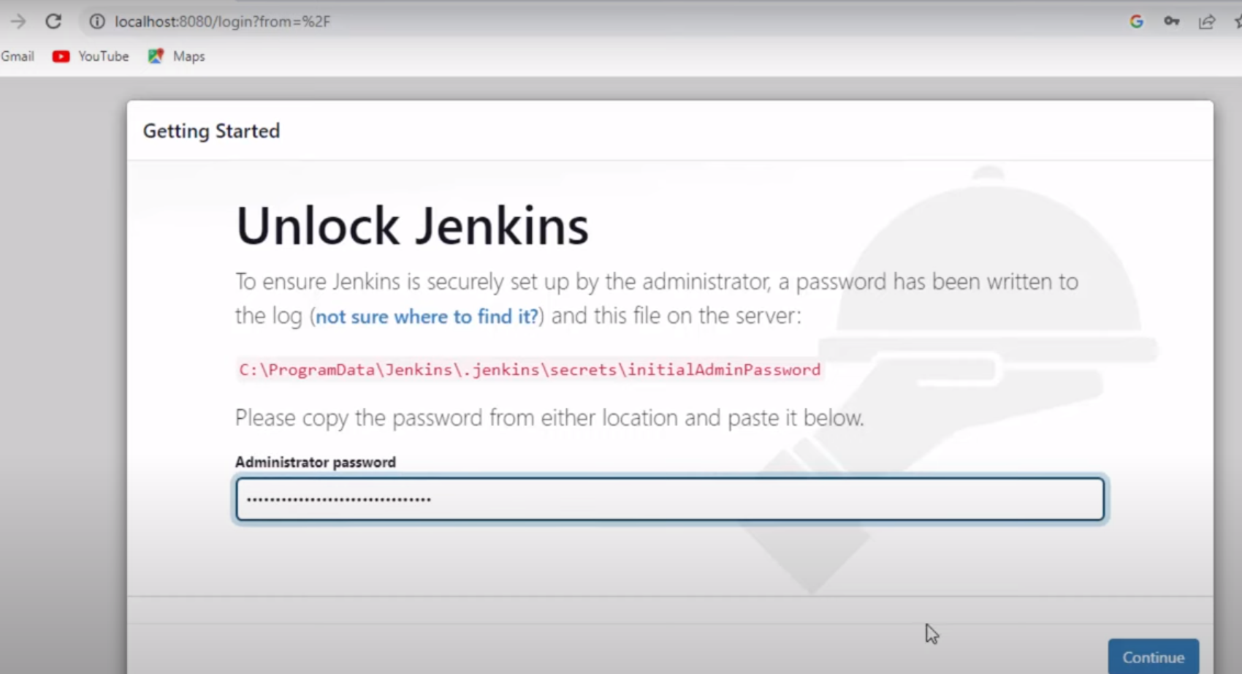

Paste as here. And click continue.

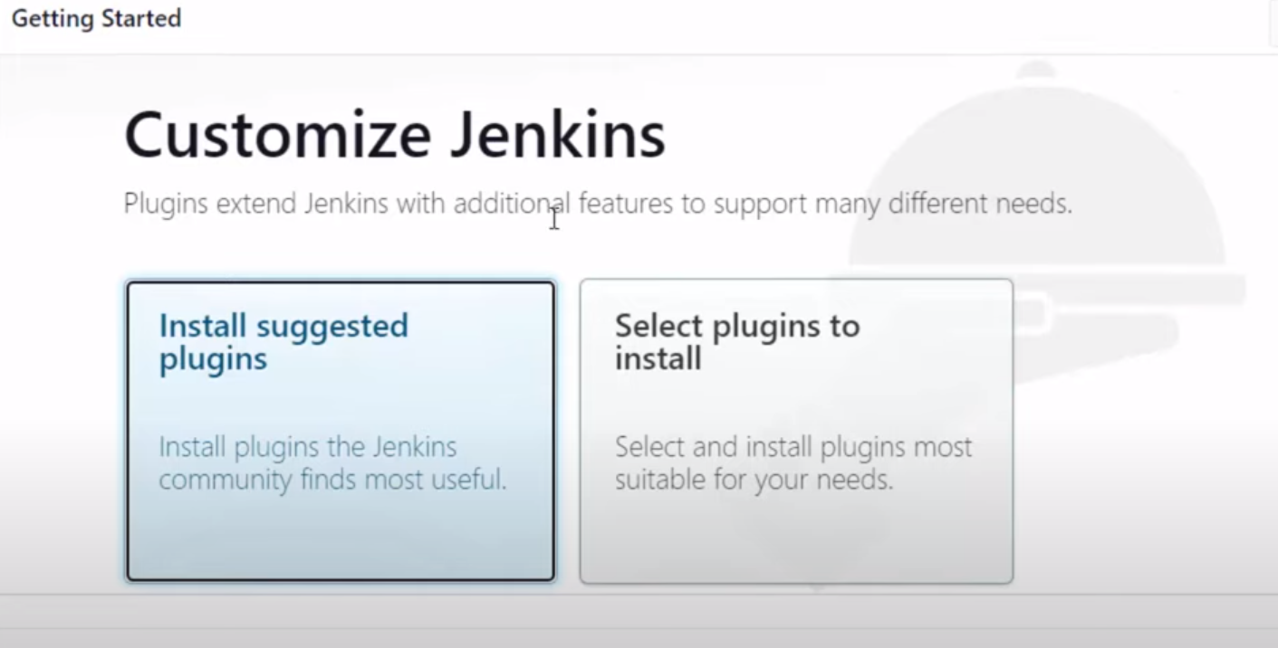

Click on intall Suggested plug in.

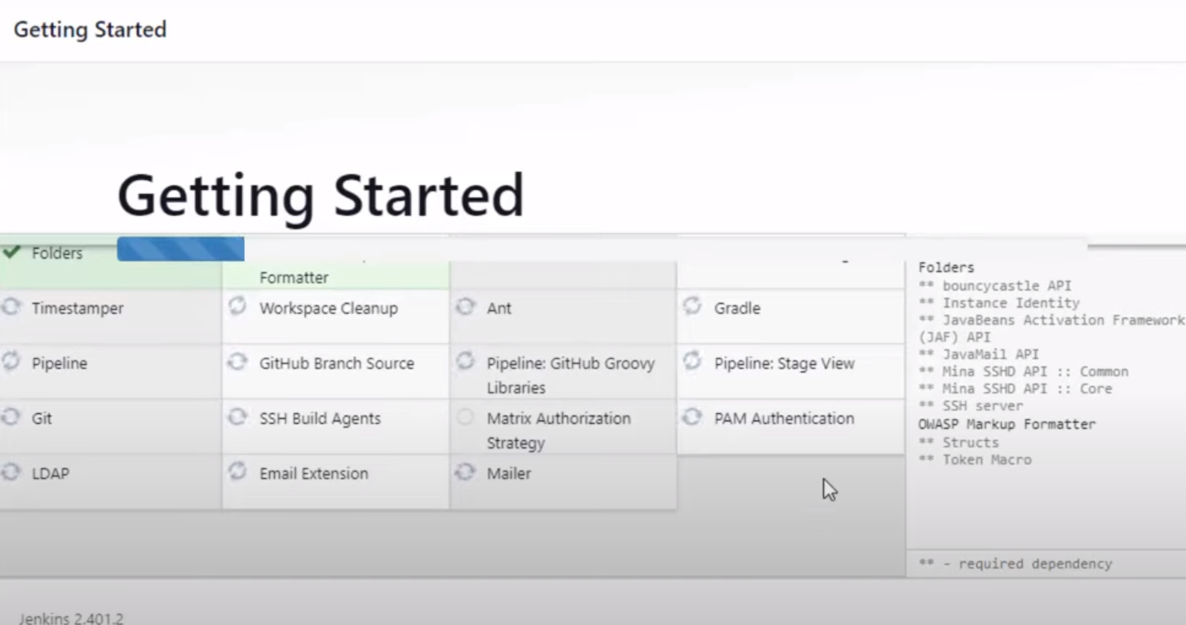

Wait till all the plugins are installed.

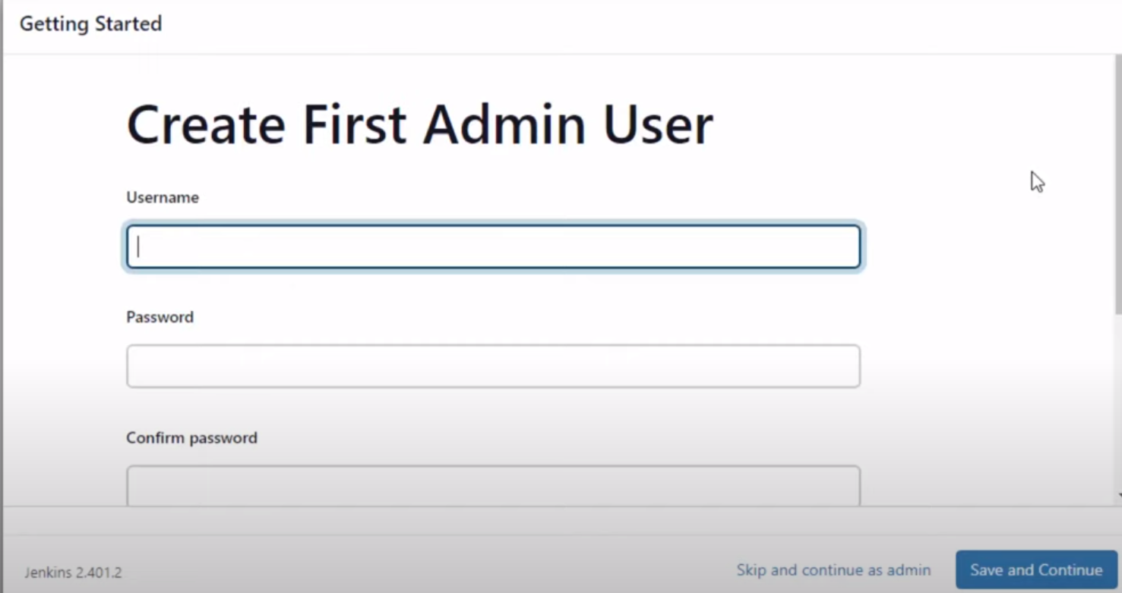

Complete the form by giving all the details.

Please remember the Username and password. As it is very difficult to reset the password.

You wont find any forgot password option.

Click save and continue.

Keep the same port number which we have given at the time of installing Jenkins.

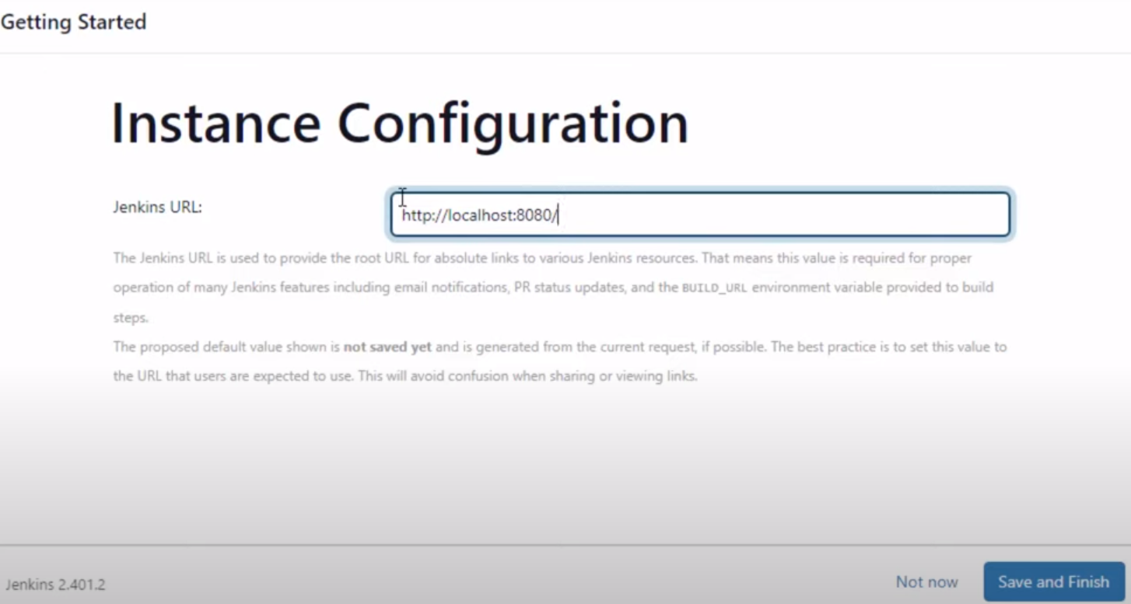

Save and finish

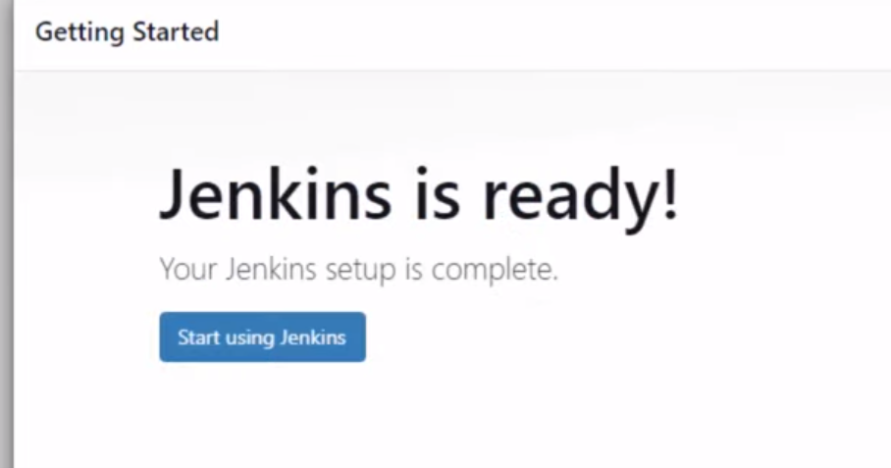

Click on start using Jenkins tab or localhost:8080 also

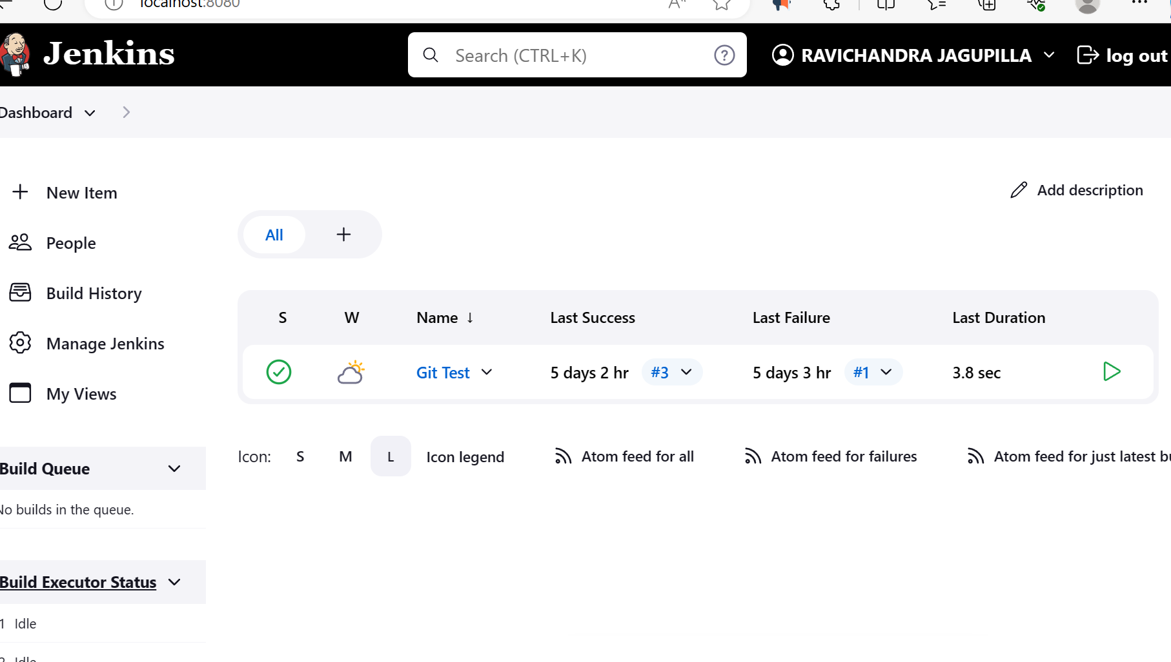

Trouble shoot:

[How To Reset Jenkins Admin Password | Reset Jenkins Password Simple Steps | Forgot Jenkins Password - YouTube](https://www.youtube.com/watch?v=vkezUwXr3ZQ&t=228s)